11/9/2025 4:28:59 PM
NAME: HAFSAT HASSAN MUHD | Age: AD | Sex: F | Ref No:00010
Clinical Details: USG Pelvic |  |  | US:10

REAL TIME PELVIC ULTRASONOGRAPHY EXAM: REVEALED:

URINARY BLADDER: Distended with urine with normal mucosal thickness. No gross masses or stone seen.

UTERUS: The uterus is gravid, containing moderate echogenic product of conception in the uterine cavity, it measured 16 mm x 26 mm at time of scan. The anterior and posterior myometrium appears normal. Right and Left adnexa are free.

CUL-DE-SAC: Mild free fluid collection.

IMPRESSION: The USS features are suggestive of RPOC (Incomplete Abortion).

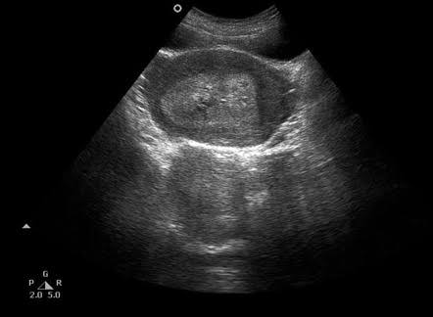

Ultrasound specialist

